Name ______________________________________ Period ________

Storage Chest Plan of Procedure #7
Cutting the Lock Miters
- Get your two End Panels and both Front and Back Panels.
- You will need to cut a Lock Miter Joint on all the edges of your panels before assembling your storage chest.
- Use the Lock Miter Shaper on the SHAPER TABLE to cut these.
- HAVE THE TEACHER HELP WITH THIS PROCESS.
- Cut both edges of your End Panels first. Have the boards face up when doing this. See Picture.
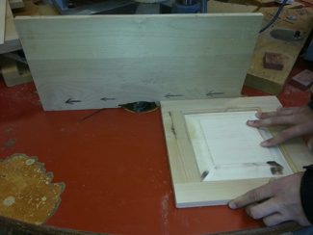
- Use two Hand Spring Clamps to Clamp the SPACER BOARD to the table. Be sure to align the small arrows. See Picture. 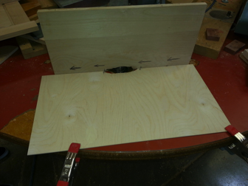
- Cut both edges of your Front and Back Panels. Have the boards face out. VERY IMPORTANT THAT YOUR BOARD IS UP AGAINST THE FENCE. SEE PICTURE.
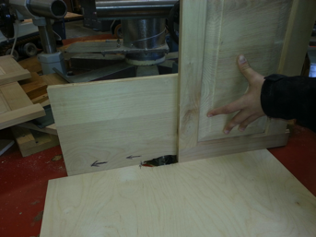

- Remove the Spacer Board and Hand Spring Clamps from the table before leaving the Lock Miter Shaper.
- Dry fit your Storage Chest together to see if it fits. Be careful not to break any joints at this point. Do NOT glue anything yet. See Picture.
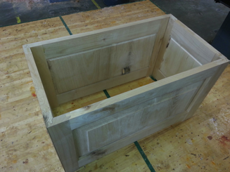
- Have the teacher check your project.
- Teacher Signature ____________________________
- Hand this paper in to the Turn-In folder.

