Name ______________________________________ Period ________

Storage Chest Plan of Procedure #4
Front and Back Panel Rails and Stiles
- Get your two End Panels from the previous plan of procedure.
- Glue the Panels together by ONLY PUTTING GLUE ON THE ENDS OF THE RAILS. This will allow the panel to “float” which allows for expansion and contraction of the panel.
- Use two STEEL BAR CLAMPS to clamp the joints tight. Allow to dry for at least 30 minutes.
- Get a board from the wood storage room that is more than 5” wide. Be sure to get the type of wood that you plan on using for your Storage Chest.
- Go to the RADIAL ARM SAW or MITER SAW and trim off any cracks off one end of your board.
- Use the RADIAL ARM SAW or MITER SAW to cut your board to a rough length of 40” and another board to a rough length of 28”. Put any remaining part of your board back in the wood storage room.
- Use the JOINTER to joint one edge of each board until flat. Remember to use push sticks if your board is shorter than the fence.
- Use the TABLE SAW to cut the 40” long board into two boards each 2 ½” wide and the 28” long board into two boards each 2 ½” wide.
- Use the PLANER to surface all your boards down to 13/16” thick.
- Use the MITER SAW to cut your boards to the exact length of your Front and Back Panel Rails and Stiles. You will need 4 stiles each 13 ½” long and 4 rails each 18 ½” long.
- Label each board with the part name (Rail or Stile).
- Mark an “X” on the best face of each of your Rails and Stiles.
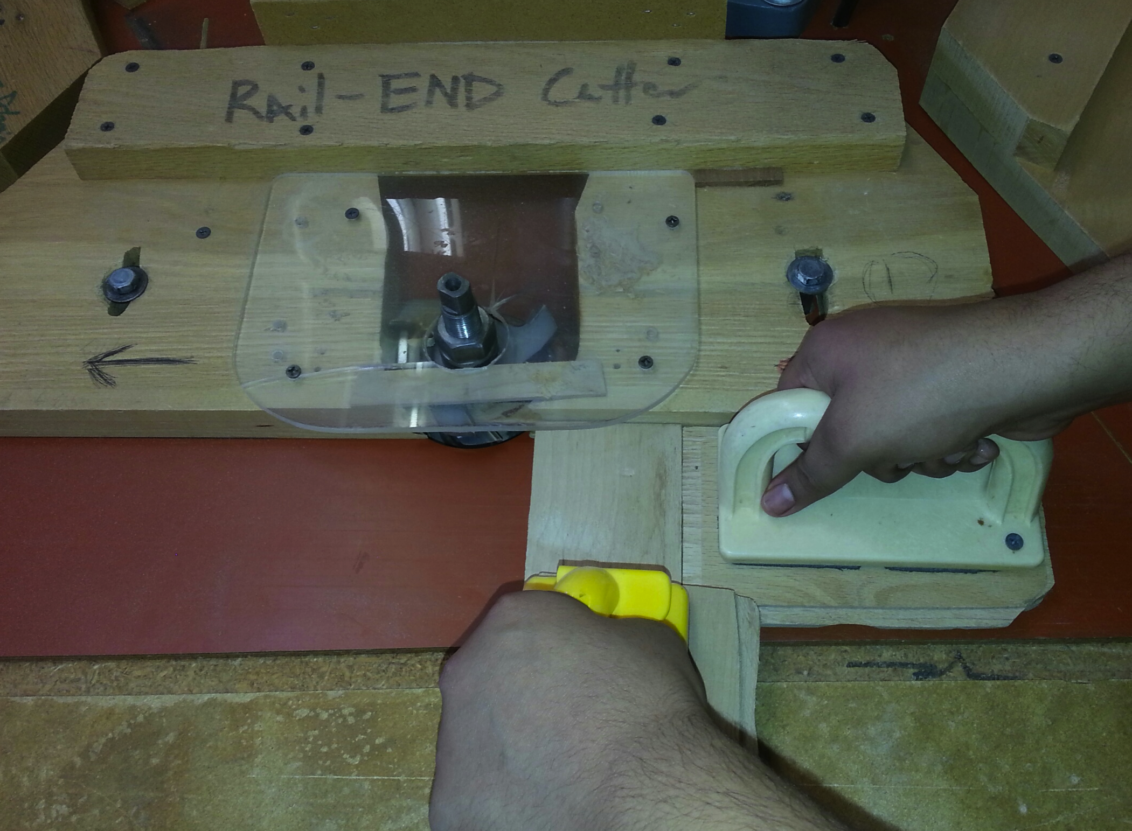
- Use the “Rail-End Cutter” Shaper to cut BOTH ENDS of your RAILS ONLY. Remember to use the Push Sticks for this. Place the face with the “X” down. (See Picture).

- Use the “Stile Cutter” Shaper to cut ONE EDGE of your RAILS AND STILES. Place the face with the “X” down and use the POWER FEED to pull your board through. Be sure the boards are tight against the fence when feeding your boards into the power feeder.
- Write your name on every board and have the teacher check off your boards.
- Teacher Signature _______________________
- Hand this paper into the Turn-In folder.

