Name ______________________________________ Period ________

Storage Chest Plan of Procedure #2
Shaping the Rails and Stiles
- In order to make the End Panels for your Storage Chest you will be making what is called a “Raised Panel”. To do this you will use the Shaper Table to “shape” your Rails and Stiles.
- Mark an “X” on the best face of each of your Rails and Stiles.
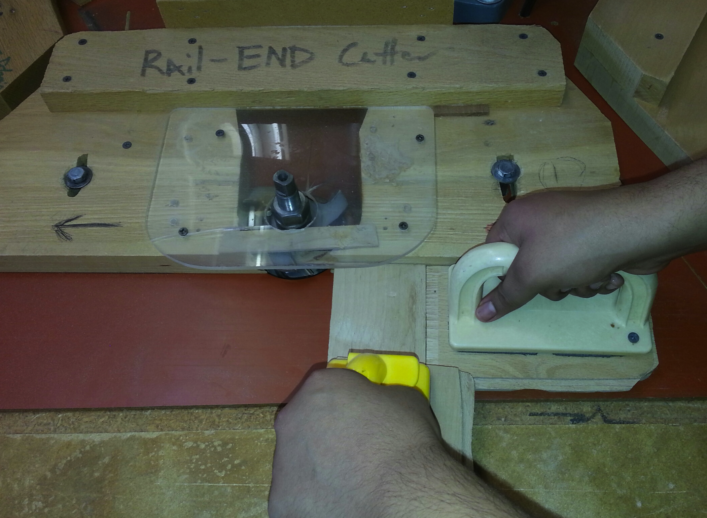
- Use the “Rail-End Cutter” Shaper to cut BOTH ENDS of your RAILS ONLY. Remember to use the Push Sticks for this. Place the face with the “X” down. (See Picture).

- Use the “Stile Cutter” Shaper to cut ONE EDGE of your RAILS AND STILES. Place the face with the “X” down and use the POWER FEED to pull your board through. Be sure the boards are tight against the fence when feeding your boards into the power feeder.
- Teacher Signature _______________________
- Hand this paper into the Turn-In folder.

