Name ______________________________________ Period ________

Storage Chest Plan of Procedure #14
Attaching the Hinges
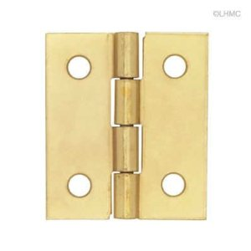
- You will need the following items before attaching your hinges:
- 2 butt hinges
- 8 small 5/8” long screws
- Cordless Drill with Phillips driver bit
- 1/16” twist bit

Butt Hinge
- Figure out which part of your storage chest will be the front and which will be the back. Place your top on the storage chest how you want it to face as well.
- Measure and mark 3” from both ends of your top where the hinges will be placed and trace the hinge outline. See Picture.
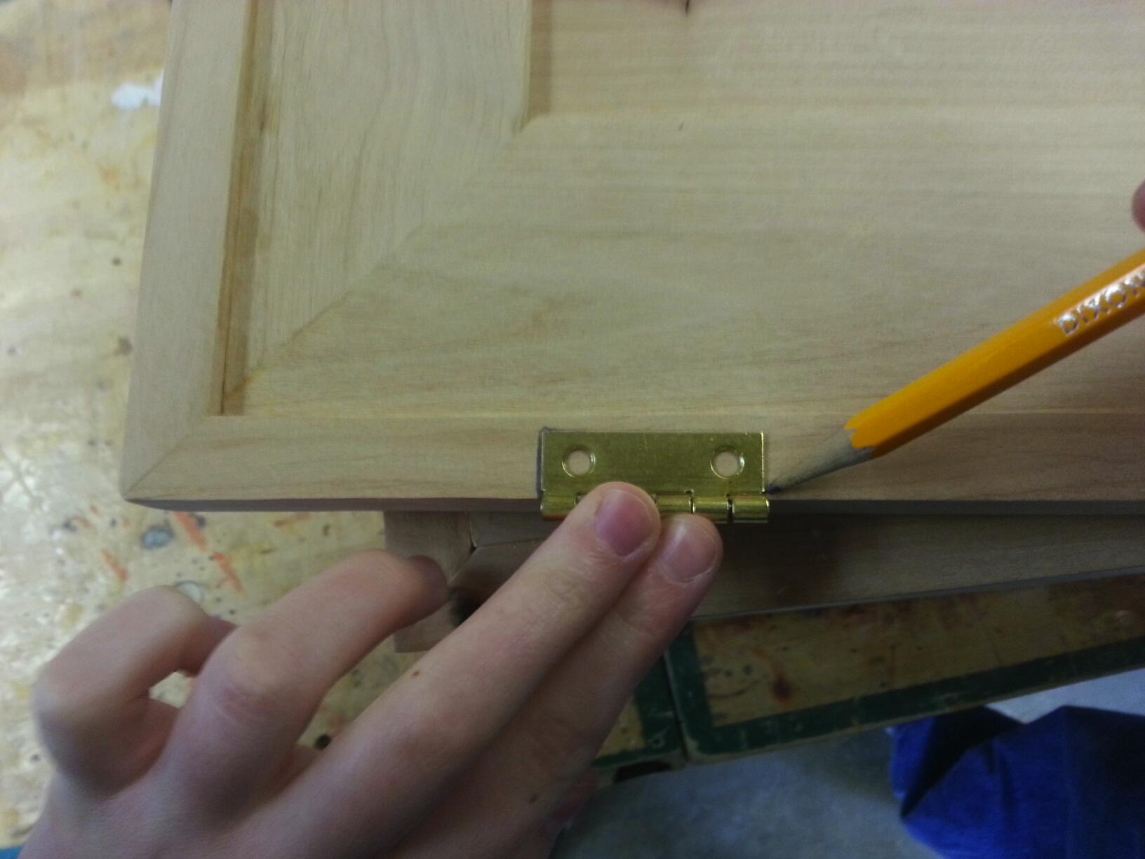
- Transfer the lines over to the topside so you can see where your hinges will be placed when the top is face up.

- Use ROUTER #1 to route out a small recess where the hinges will be inset. Line up your marks with the Centerline on the router. Start with the line on the left and slowly route over and stop on the line on the right. Have the teacher help with this.
- Place your hinges in the small recess that you routed out and line them up where you want them to be placed (3” in from the end) and trace where the screws will be attached. See Picture.
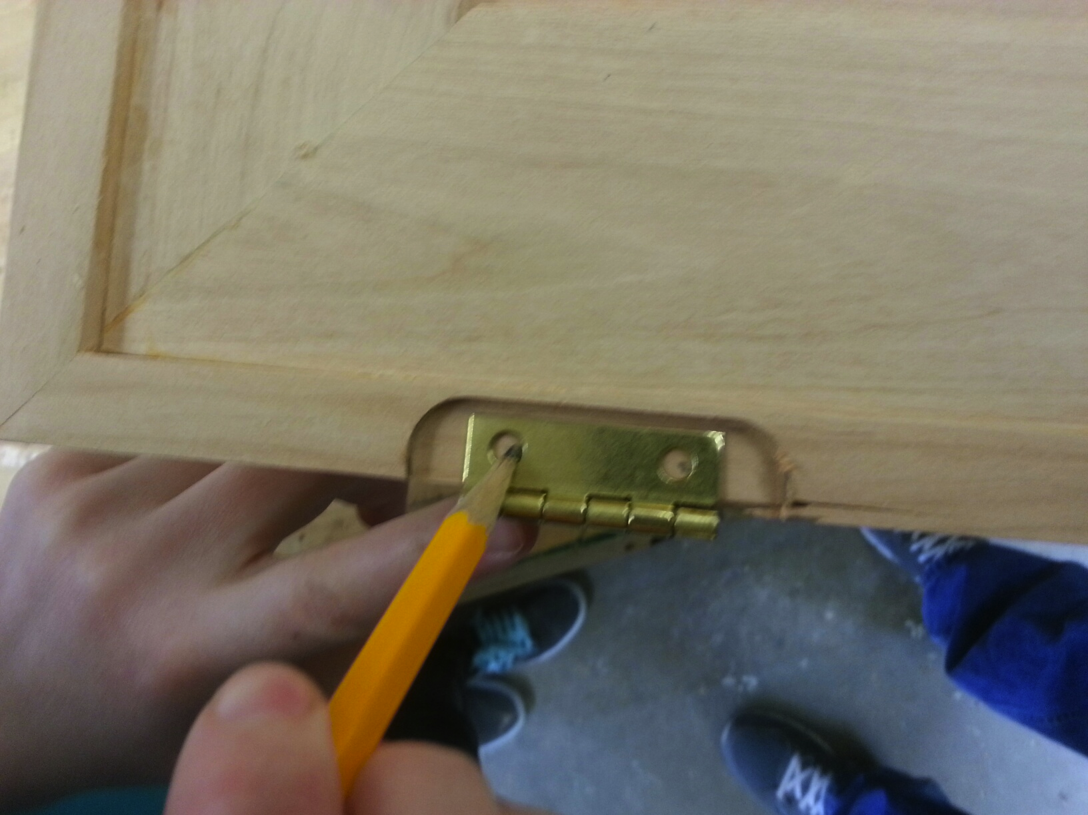
- Use the 1/16” twist bit to drill a small pilot hole for the screws to help prevent the wood from splitting.
- Use the CORDLESS DRILL with the Phillips bit to attach the hinges with the 5/8” screws. Do not screw them down too tight.
- Line up your top with the storage chest and mark where the hinges line up. Trace the holes. Be sure that the hinges are straight and everything lines up perfect on both sides.
- Pre-drill some holes with the 1/16” bit and attach the hinges to the storage chest with the 5/8” screws.
- Check to make sure that the lid closes properly and that the edges around the top are flush with the edges around your storage chest.
- Have the teacher check your project.
- Teacher Signature ____________________________
- Hand this paper in to the Turn-In folder.

