Project Ideas

Listed below are some ideas for some project ideas as well as the cost to build them.
***Any projects that use only wood from the short rack will be Free***

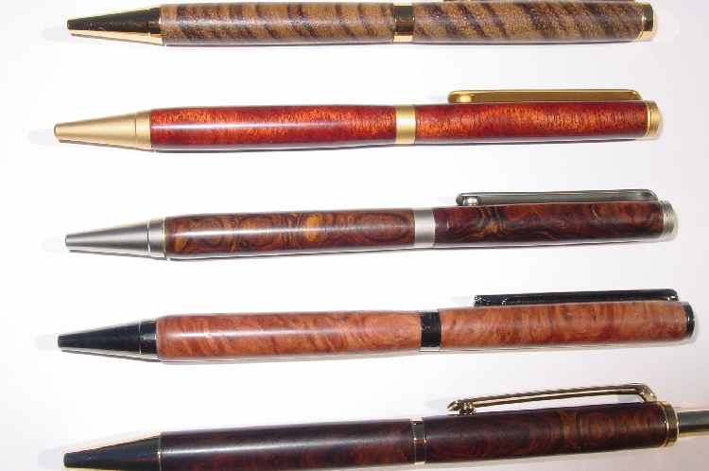  Pens - $4.00  Lathe projects –  Small- Free, Large- $2.00 | 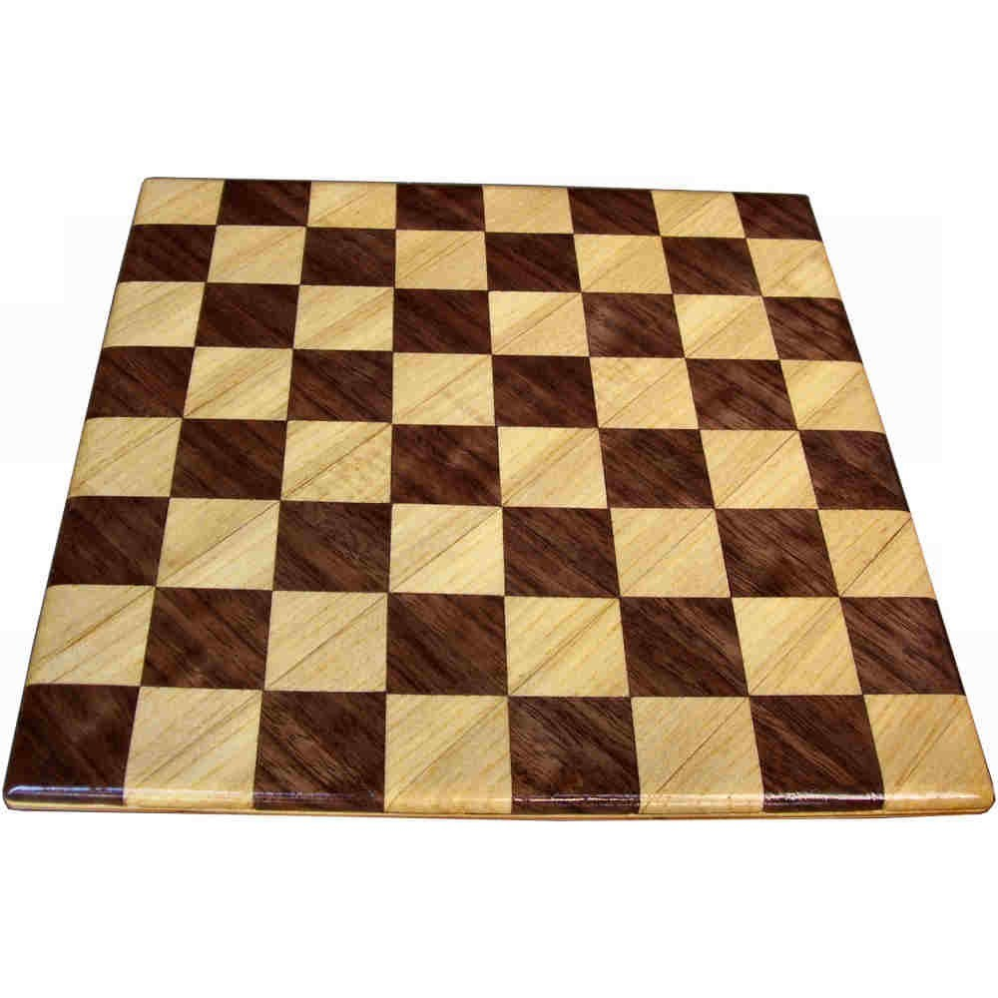  Chess Board-$10.00 | 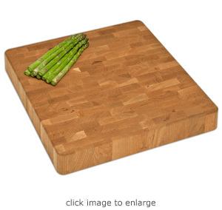  Cutting Board- $5.00
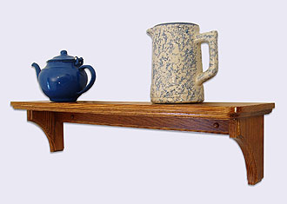  Wall Shelf - $3.00 | 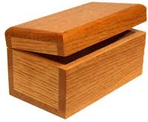  Box/Jewelry Box - $4.00 | 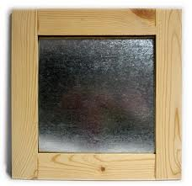  Magnet Board - $5.00
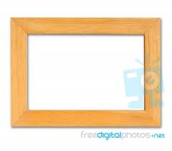  Picture Frame –  Cost depends on size | 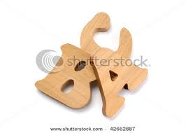  Name Letters - Free | 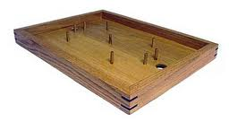  Penny Soccer - $3.00
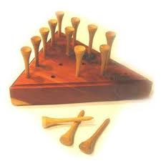  Golf Tee Game - Free | 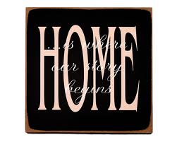  Wood Sign - $2.00 | 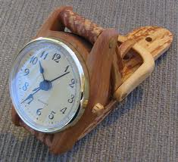  Watch Clock - $12.00

