Name ______________________________________ Period ________
End Table Plan of Procedure #8
Attaching D-Ring into End Table
- Get your D-Ring and Table.
- Measure the distance between Rabbet Joints near the back legs of your table. You need to measure from the inside of each rabbet joint. Write down that measurement on you D-Ring.
- Use the PANEL SAW to trim off 1/8” to 1/4” off one end of your D-Ring. Make sure to cut the side that has the END GRAIN showing.
- Use the TABLE SAW to cut your D-ring to the length that you measured between the rabbet joints. You wrote this measurement on your D-Ring.
- Check to see if the D-Ring fits into your table. See Picture: 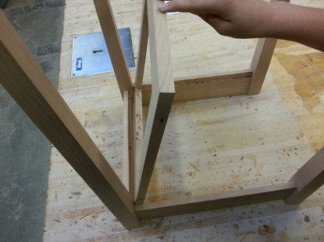
- You will need to notch out the corners of your D-Ring where the Legs get in the way. Place your D-Ring into each rabbet joint of your sides and back and mark a line where the D-Ring hits each leg. See Pictures: 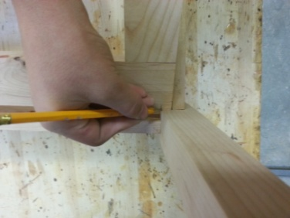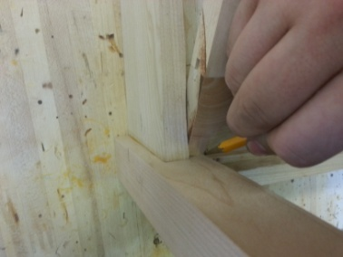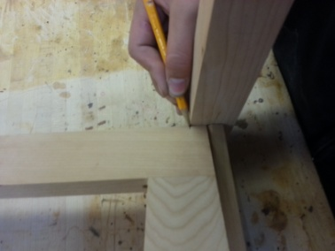
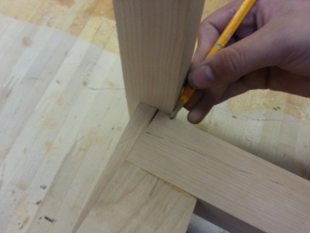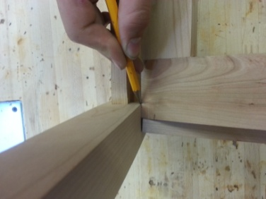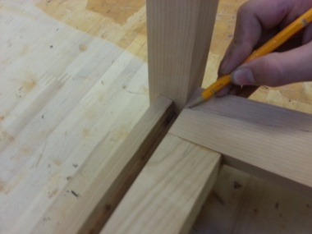

- Extend your lines to have your marks meet. Your D-Ring will look something like this:

- Use the BANDSAW to cut out each corner. Be sure to leave your lines when cutting. Check to see if your D-Ring fits into your table. If not, then check to see which notch needs to be cut more.
- Once your D-Ring fits into your table you can glue and clamp it into place.
- Spread glue into each rabbet joint. Be sure to spread the glue so it covers the entire rabbet joint. Place your D-Ring into the table and use several HANDSCREW CLAMPS to clamp your D-Ring tight.
- Wipe up any excess glue before it dries.
- Teacher Signature ____________________________

