Name ______________________________________ Period ________
End Table Plan of Procedure #6
End Table Assembly Part 1
- Get your 2 sides and 1 back and mark an X on the best looking face of each board.
- Use the ROUTER #3 in the orange router table to route a rabbet joint down the edge of your sides and back. Have the face with the X facing up. Only route 1 rabbet on each board.
- Get your 4 legs and mark an X on the two edges that are tapered. To figure out which edges are tapered place the leg down flat on a table and if it rocks, then the edge touching the table is tapered.
- Set up your table with the sides, back, and legs on a benchtop. Make sure that all the tapered edges are facing toward the inside of your table and the rabbet joints are facing the inside. See Picture.
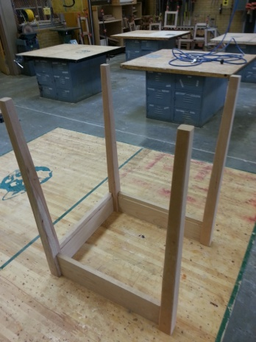
- Number off your legs, sides, and back with a 1-1, 2-2, 3-3, etc. so you will know how your boards will be put together later.
- Mark a center line near the ends of your sides and back.
- Transfer the center line onto the legs where the lines meet.
- Have the teacher check your boards and marks.
- Teacher Signature _______________________
- Hand this paper in to the Turn-In Folder.

