Name ______________________________________ Period ________
End Table Plan of Procedure #14
Attaching the Top
- It is important that you DO NOT glue your top to your table. Instead you will be attaching your top with SCREWS only.
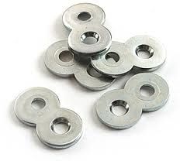
- You will need the following Drill Bits and Hardware in order to attach your top:
  - 4 Figure 8 connectors
  - 8 small screws (5/8” long)
  - ¾” Forstner Bit
  - 3/8” Twist Drill Bit
  - Long Phillips Screwdriver Bit
Figure 8 Connectors
  - Cordless Drill

- Place the 4 Figure 8 connectors on the top edge of your table sides and trace the inside holes on your board. Have the Figure 8’s about 2” in from the legs. The middle indent of the Figure 8 will be lined up with the inside edge.
- Use the ¾” Forstner bit to drill a very small hole (about 1/16” deep) where you marked your holes. DO NOT DRILL TOO DEEP. Check to make sure the Figure 8’s will be flush with the top edge of your boards. See Picture.
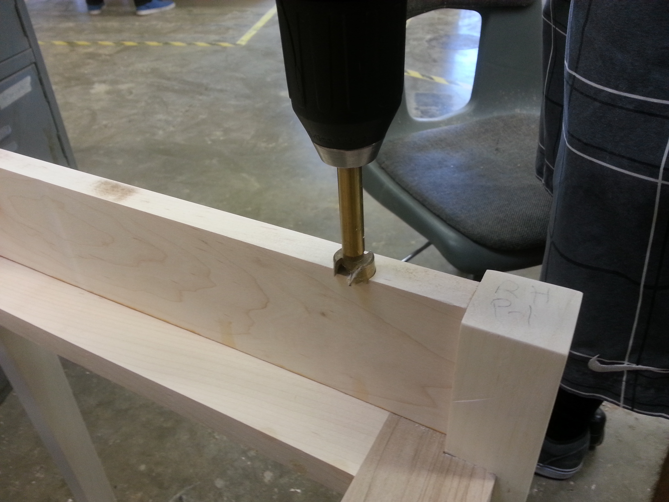

- Attach the Figure 8’s using the small screws and a cordless drill with the Phillips Screwdriver bit. See Picture.
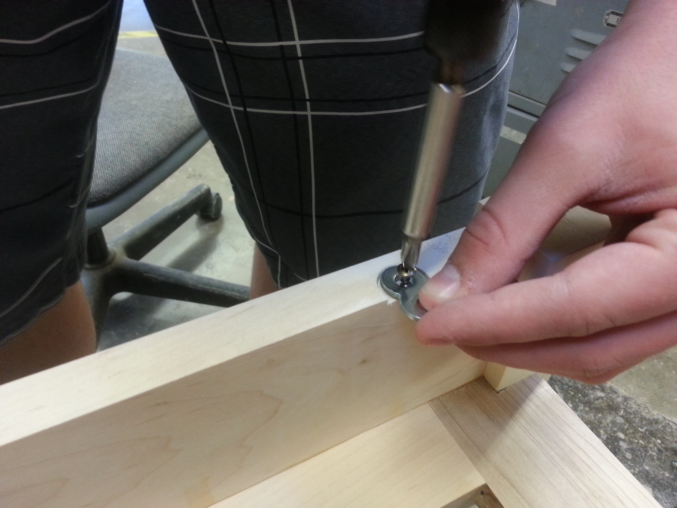
- Use the 3/8” Twist Drill Bit to drill a hole through your D-Ring directly in line with the Figure 8’s. Drill from the bottom of your D-Ring. Do Not just Guess where the hole will be drilled. Measure to see where the Figure 8 lines up and mark it on the bottom of your D-Ring. See Picture.
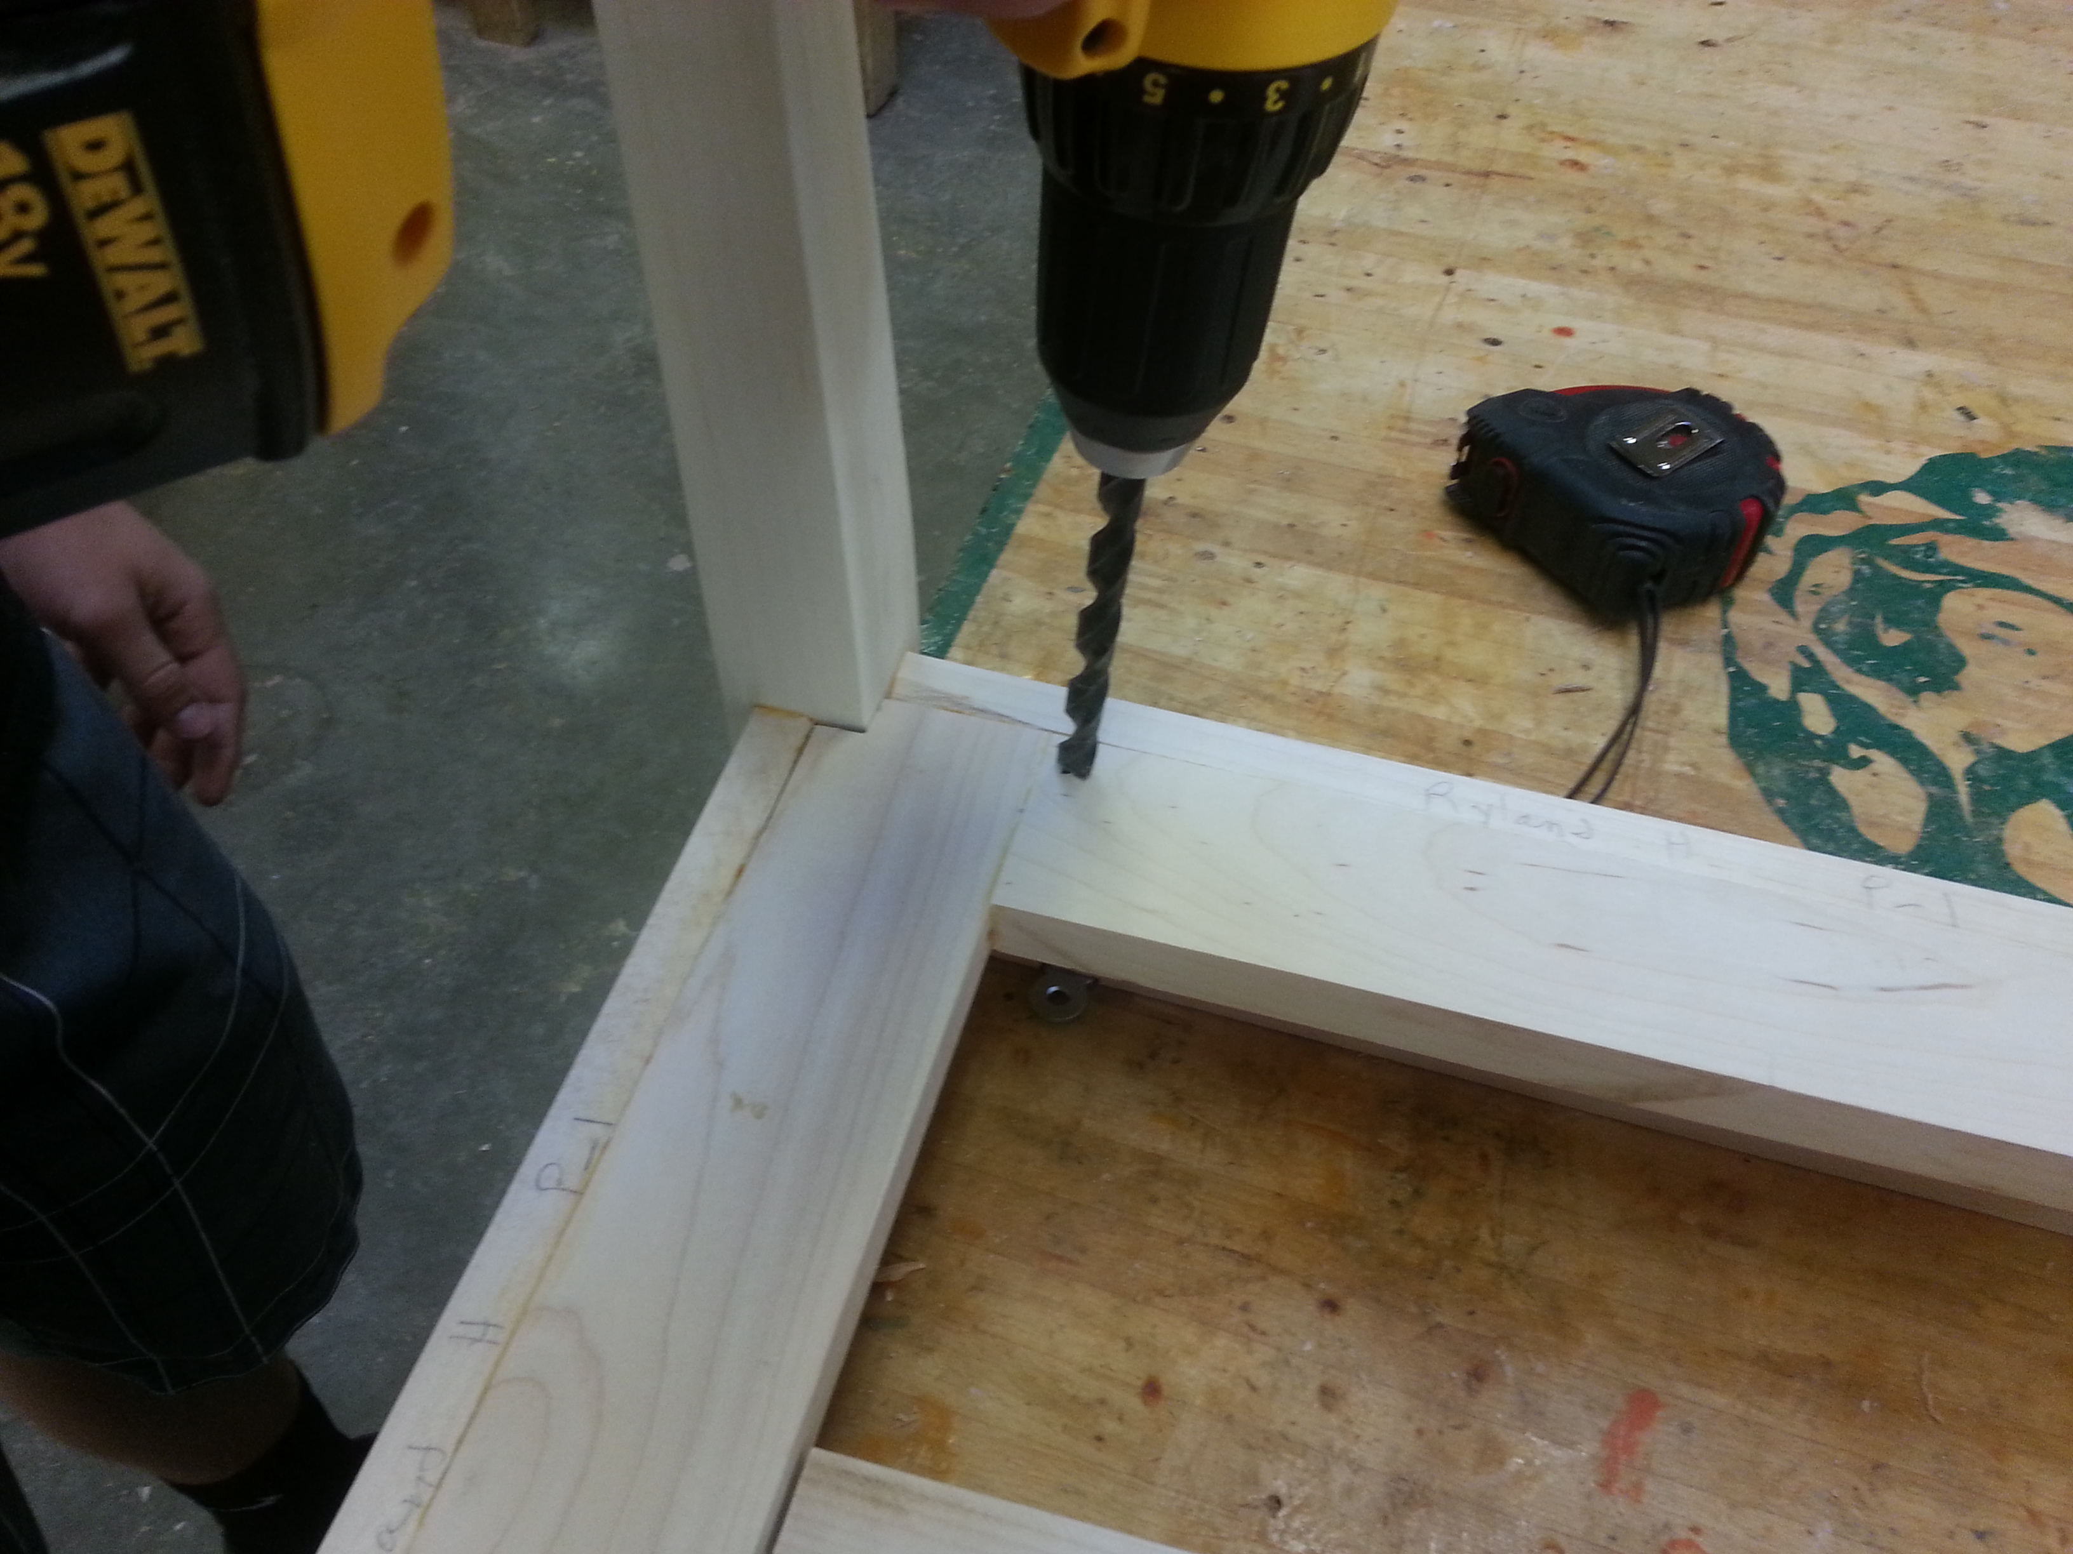
- Place your Top upside down on a bench and place your table on the top. Line the back legs up flush with the back edge of your top. Make sure to have equal hangover on the left and right sides of your top.
- Use the Long Phillips Screwdriver bit in a Cordless Drill to screw the top on to your table. Be sure the screws are tight down.
- Teacher Signature ____________________________________

