Name ______________________________________ Period ________
End Table Plan of Procedure #10
Top Part 1
- Look at your ESTIMATING SHEET to see what the dimensions are for the TOP of your End Table.
- You will need to glue boards together in order to get your boards wide enough for your top.
- Get a board from the Wood Storage Room and figure out how many boards you will need to cut from it in order to glue your top.
- Use the RADIAL ARM SAW or MITER SAW to cut several boards 19 ½” long. Remember to cut off any cracks off the end of the board first. You will need enough boards to have the width be more than 21” wide when you put the boards edge to edge.
- Use the JOINTER to joint BOTH EDGES of every board.
- Place your boards together and figure out how your boards will best look. Remember the order of importance when gluing boards together.
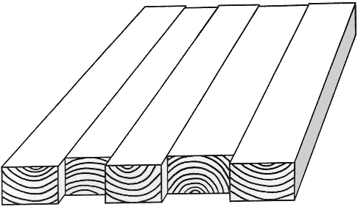
  - Looks Matter – choose the best looking faces to be showing.

  - Alternate End Grain –

  - Grain Cathedrals facing the same direction - 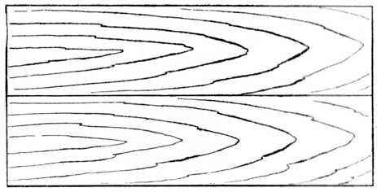
- Once you figure out how your boards will be placed, draw a large triangle over all your boards so you know how to easily set up your boards when gluing.

- You will need at least 3 STEEL BAR CLAMPS in order to glue your boards together.
- Use the Glue Tables when gluing your boards together. If there is no room, on the glue tables, then you can glue your boards on a bench top, but make sure to place some butcher paper down to prevent glue from dripping on the bench tops.
- Spread Glue over the entire edge of each board that will be glued. Have the BAR CLAMPS alternate on top and bottom of your boards. 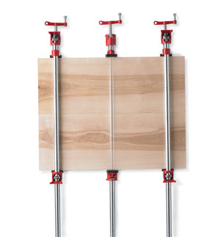
- Keep boards flush while tightening clamps.
- Let the glue dry for at least 30 minutes or until the glue has dried.
- Write your name on your top and set top aside to dry.
- Teacher Signature _______________________
- Hand this paper in to the Turn-In Folder.

